THE USE OF MULTIPATCH FOR THE OBJECTS IN 3D DIGITAL CARTOGRAPHY
M. Caprioli, B. Figorito, A. Scognamiglio, E. Tarantino
Polytechnic University of Bari -Italy
m.caprioli@poliba.it; benedetto1980@libero.it; a.scognamiglio@poliba.it; e.tarantino@poliba.it

Abstract
With this study the potentiality of the CAD-GIS tandem using the features type Multipatch with distinct softwares was evaluated, in order to allow spatial processing in 3D GIS environments, also divulged by web.
The Multipatch permits to encapsulate complex objects in a compact way and to add also textures on surfaces, providing a real objects visualization. Such technique is not still used because commercial GIS softwares haven’t specific tools to create feature 3D Multipatch.
The processing works were executed with the aid of some commercial softwares, such as ArcScene–ArcInfo 9.1, SketchUp5 e AutoCAD 2006 to investigate the real possibility to use this methodology by Cartography producers.
The 3D objects made with integrated procedures were next processed with GIS tools, verifying the effective possibility of executing three-dimensional thematic queries in visualization environments.

Keywords: Cartographic objects, CAD, 3D GIS, Multipatch.

Introduction
In many interactive computer graphics applications, maps in three dimensions are central to enabling the exploration, presentation and manipulation of geographical data. 3D maps can be used by GIS specialists as tools for presentation of spatial data to inexpert users [8]. Advanced graphical libraries such as OpenGL and VRML enable effective modeling by rendering the third geographical dimension [11]. All the above representations only permit the user to view map layers as a single entity rather than being able to visualize the layers as a combined overlay representation and as individual entities in the same way that is possible with 2D GIS [4].
In literature there are substantially object oriented and topology oriented models. In the first one, addressed to visualization, topology and spatial relations derive from the object structure, while in the second one, connected to analysis, relations are explicitly defined between one object and its neighbours [13].
All the 3D vectors data models share the set of geometric primitives, structured in different way for every specific application [2, 5, 9, 10, 12].
The common components of any model are points, lines and solids.
The point is the most diffused in GIS environment, even if in real world there are a few entities that have not area or volume. The point is easily visualized in a three-dimensional space and is the basis for many spatial representations.
The line is a set of points connected as single one-dimensional primitive and, as the points, it is an abstraction of real objects. In the 3D space the lines are used to schematise for example cables, pipes, linear elements, without visualization of the height and the diameter or the thickness of objects.
The polygon defines a surface with common attributes and it is a two-dimensional primitive constituted by one or more closed lines. It is used to represent planes, surfaces or all entities that have a two-dimensional extension without thickness. Polygons are utilized also to create 2,5 D data: the TIN is the classical example of a polygons collection with a surface and without thickness, but with a variable height.
The solid is a primitive constituted by a set of closed polygonal faces. This is the true 3D primitive that could represent all the entities if it was easier implemented in GIS software. The definition of the order of border points in a solid is very complex and hard to implement in a geodatabase.
Also the model proposed by the “Intesa GIS” between the Italian State and Regions is not oriented to visualization and to analysis of 3D objects. The hybrid mode for 3D representations, through the union of a 2D surface with a 3D ring (border of an object), is not suitable to conventional data processing of the next generation GIS [1].
On the contrary, a model strongly oriented to representation of three-dimensional objects in urban contexts is the CityGML, widely investigated by public and private research groups [7]. This cartographic model uses five levels of detail to represent objects and permits the insertion of texture, by using 3D virtual models aimed to sophisticated analyses in different application fields as simulations, urban data mining, facility management and also thematic complex queries. Moreover, it is implemented as application scheme for the international standard Geography Markup Language 3 (GML3). Nowadays, the implementation costs of CityGML, even if it guarantees the creation of a real 3D GIS, are still expensive for an immediate applicability.
The GML3 could represent one of the most innovative prospects towards the integration of complex and georeferenced geometries, but the instructions suggested by the Open Geospatial Consortium (OGC), in order to define the structure of the information, the metadata, the types of geographical objects, the geometric and topological relations of the entities, are hardly implemented in practical applications because of their complexity.
In the light of the Italian and international experiences in 3D GIS context, this work proposes the evaluation of the power of CAD software to manipulate three-dimensional data and the properties of the Multipatch feature type in shapefile format to represent complex objects in GIS environment.

Multipatch procedures for three-dimensional objects construction
The building of Multipatches allows to encapsulate complex objects in a compact way and to add also textures on surfaces [3], providing a real objects visualization. This instruments is not yet utilized among GIS community because commercial softwares have not specific tools for the creation of 3D Multipatch features.

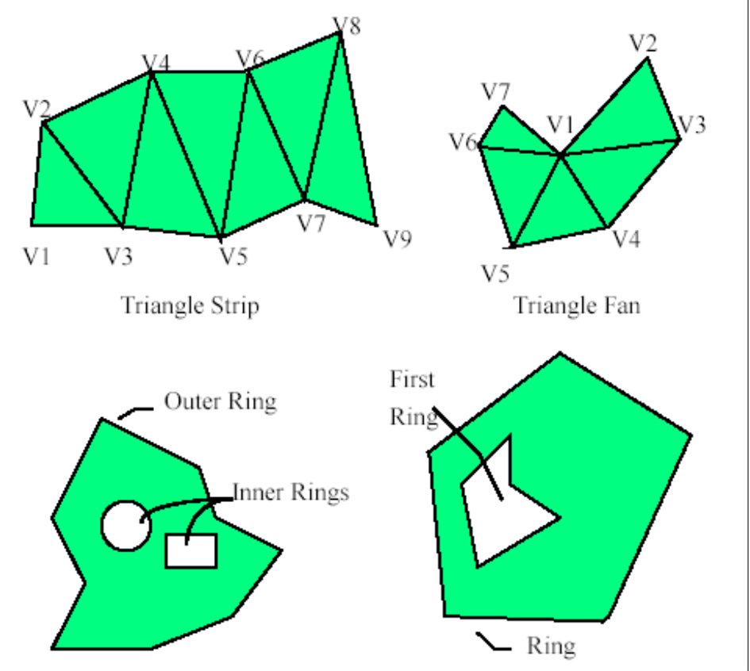
Figure 1. Geometries of Multipatch (Source by ESRI Shapefile Technical Description, 1998).

The Multipatch is constituted of a combination of three-dimensional surfaces (Figure 1), represented by the following geometries [6]:
- Triangle Strip. It is a strip of triangles linked among them, in which every vertexes (after the first two) determines a new triangle. A new triangle is always formed by connecting the new vertex with its two immediate predecessors.
- Triangle Fan. It is a linked fan of triangles, where every vertex (after the first two) completes a new triangle. A new triangle is always formed by connecting the new vertex with its immediate predecessor and the first vertex of the part.
- Outer Ring. It is the outer ring of a polygon.
- Inner Ring. It is a hole of a polygon.
- First Ring. It is the first ring of an unspecified polygon.
- Ring. It is a ring of an unspecified polygon.
A Multipatch is an object to all intents and purposes, similar to conventional objects (as points, lines, polygons) on shapefile format and alphanumeric attributes.
Commercial GIS softwares does not allow the execution of spatial queries on Multipatch. Such limit is due to the lack of 3D spatial operators. The current version of ArcGis-ArcInfo 9.2 had timidly introduced only a few functions for the editing of the Multipatch, without permitting the real development of feature type.
A detailed discussion of the tested procedures with the integrated use of CAD and GIS tools follows, in order to test the real possibility of using such methodologies by cartographic producers.

  - Procedure with ArcScene – ArcInfo 9.1
The most simple procedure to produce the Multipacth is based on the use of a tool inside ArcScene-ArcInfo 9.1. The creation of Multipacth is articulated in three main phases which nevertheless depend on the typology of entities to represent. The objects chosen for our tests were typical elements of urbanized territory, as caissons and roofs.
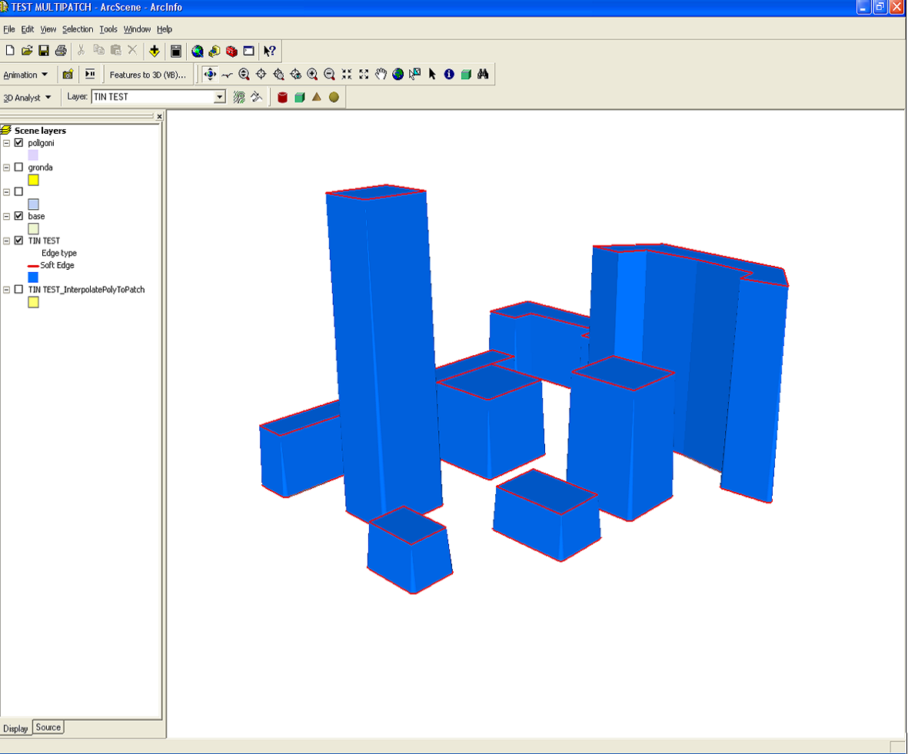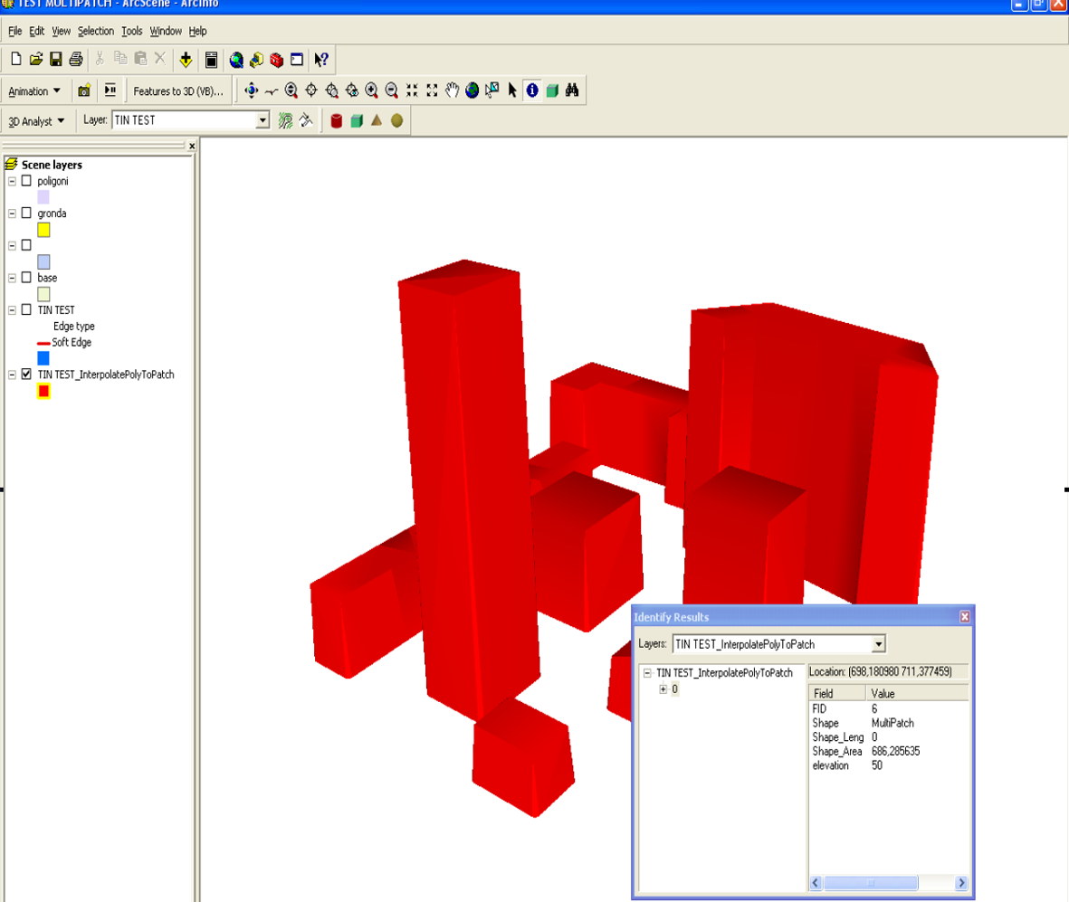
Figure 2. TINs generated from feature classes Figure 3. Multipatch objects

In the first phase the shape entity (polygons) were transformed in feature 3D, using “elevation at roof height” as input parameter for attributes.
In the second phase the TIN (Triangulated Irregular Network) from the previous created feature classes was derived (Figure 2): this operation generated planes surfaces constituted by triangles entities. The limitations in using such procedure for urbanized environments is connected to impossibility to create vertical surfaces by means of TINs. In this way all the not contiguous objects with high vertical accuracy were excluded.
In the third phase Multipatch features by means of the tool “Interpolate polygon to Multipatch” were created (Figure 3).
The whole procedure was successful because every object was constituted by an only one Multipatch. This result could be of great utility both in terms of time and realization costs, and in that applications connected to the management of topographic databases.

  - Procedure with SketchUp5
Sketchup5 is a design-software with routines which allow the realization of three-complex dimensional shapes in CAD environment. In this way it is possible to export objects created with Esri Multipatch (*.mdb) format using a proper plug-in.
The construction of Multipatch objects is composed by three main operations: the import of a shapefile, the processing and at last the export of objects.
The first phase is fundamental because the software acquires the intrinsic coordinates, by means of the import of shapefile with footprints (buildings, roads, bridges, etc.), overcoming the limit of SketchUp5 which does not permit the management of reference systems.
In the second phase the operator creates in CAD environment the objects to be represented (Figure 4a).
Figure 4a. Objects created with SketchUp 5

In the last phase the export of objects from the *.skp format to the *.mdb one of Personal geodatabase of ArcGis, in which the shapefile Multipatch is contained. This operation generates three-dimensional models with very complex shapes. The possibility to export textures also permits the creation of photo-realistic objects (Figure 4b).
The current procedure has many limits in practical applications because Sketchup5 transforms all the created objects in one only Multipatch, hardly manageable in evolved GIS environments.
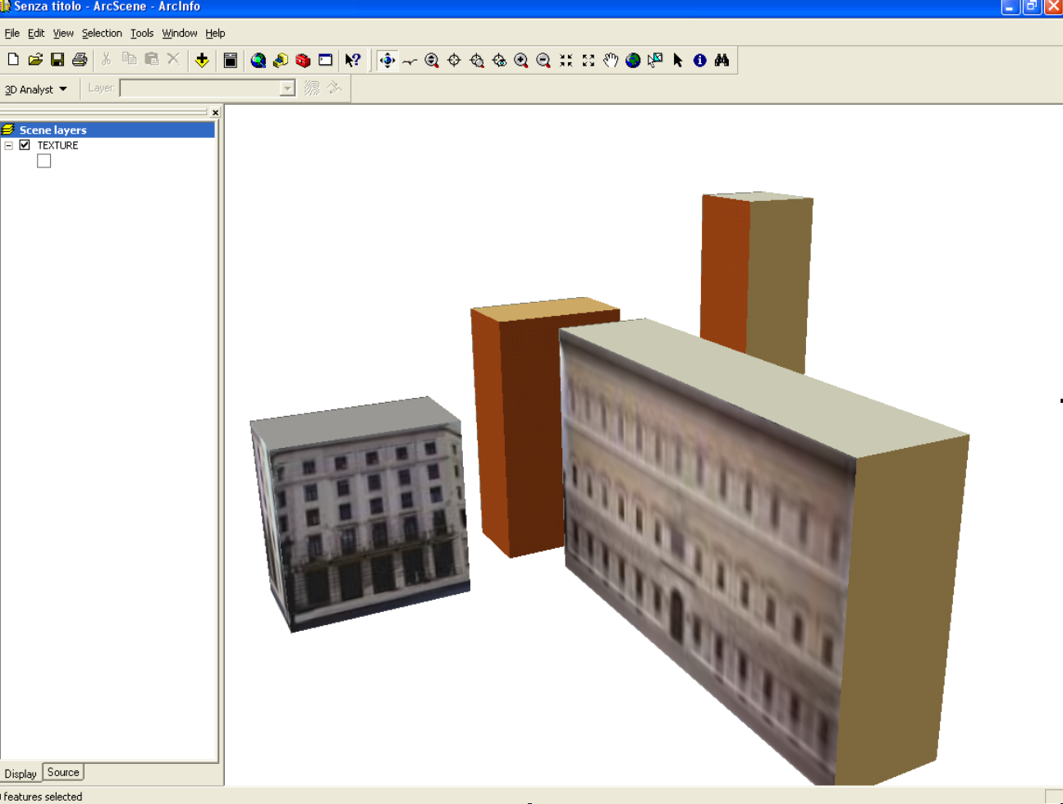
Figure 4b. Objects inserted in ArcScene-ArcInfo with textures

  - Procedure with AutoCAD 2006
This procedure utilizes Autocad 2006 as 3D modeller and CAD2Shape3.0 as software to export Multipatches. The operations for the creation of such features depend on the level of detail of objects to be represented and allow the management of complex shapes by using more Multipatches.
In the first phase different objects typologies (caissons, gable roofs, domes, etc.) were constructed using CAD instruments to create 3D surfaces.
The second phase was characterized by the processing of Multipatches on the base of previous realized objects. CAD2Shape3.0 permits the dwg files conversion in shapefile format with feature type Multipatch. Figure 5a and 5b point out the univocal representation of solid objects. In our case everyone of them shows a different colour and can be identified with alphanumeric information by means of thematic queries executed within 3D visualization ArcGis environment.
The integrated use of AutoCAD and CAD2Shape 3.0 was found very favourable one and could have a fast development because almost all cartographic production is diffused in dwg or dxf formats. The current plotting photogrammetric methods, despite the objects representation with polylines and 3D points, do not permit to final user the easy and direct comprehension of three-dimensional reality, but after an expensive editing work. The above tests could assign a wider charge to cartographic producers in term of plotting costs, but conversely final user could have an high quality product, usable in three-dimensional environments, not only for navigation and animation aims but also for query execution. The large scale urbanized territory (historical centres), with its architectural heritage, is the ideal context able to support 3D surfaces plotting with higher costs.

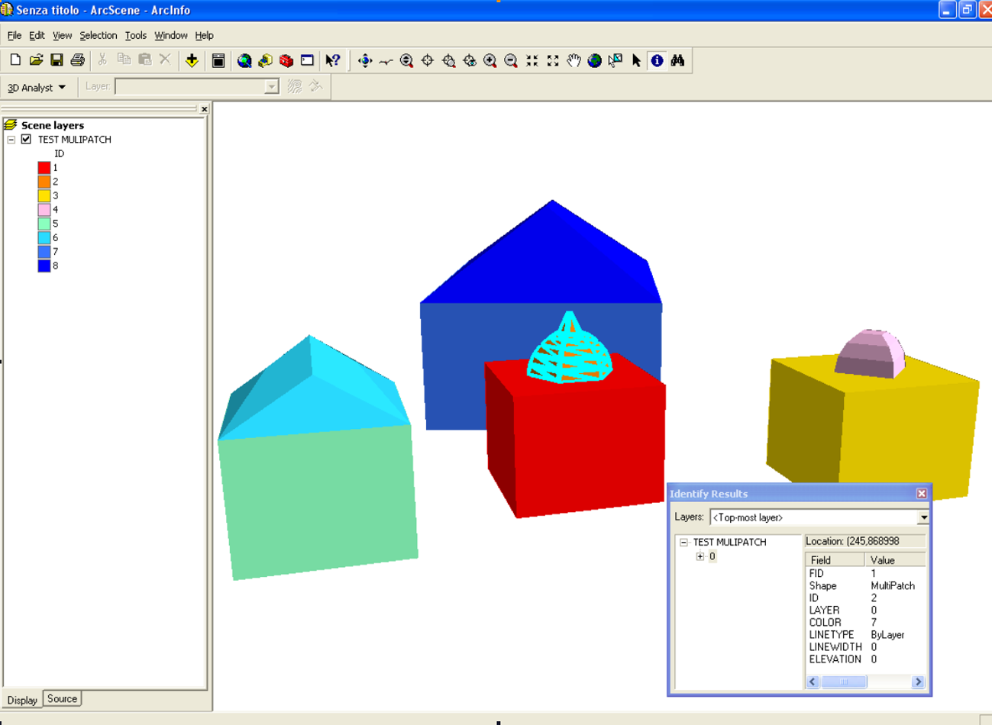
Figure 5a. Execution of thematic queries on solid objects.
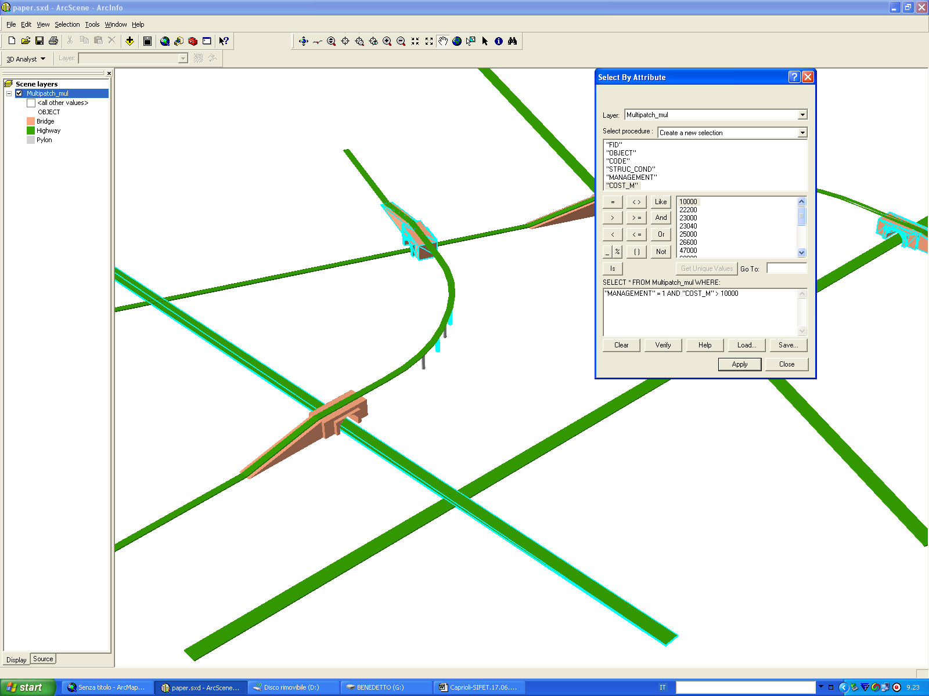
Figure 5b. Execution of thematic queries on road infrastructures.

3. Conclusion
The technical innovations proposed in this work could be considered incomplete if compared with the CityGML models, whose complexity level, in term of implementation and costs, hampers a real use in every application field.
One of our key objectives in testing of different procedures was to propose to GIS community the interactive querying capabilities inside of the 3D visualization and navigation system, in order to use them for decision making and spatial/aspatial data analysis. The implemented features have the advantage to be simple and immediately usable in current GIS softwares and could efficiently allow the retrieval and the reuse of digital cartographic archives as basic data for many application fields.
The diffusion of Multipatch objects will depend on commercial choices of CAD and GIS softwares and on the development of 3D spatial operators. The possibility of inserting textures and images on Multipatch objects will make such procedures interesting also for photo-realistic rendering of complex objects.

References
- Ammoscato A., Corsale R., Scianna A., Cartografia Numerica Tridimensionale per GIS e WEB-GIS: verso la fruizione virtuale, Proceedings of SIFET Conference, 14 - 17 June 2006, Taranto, Italy, (unpaginated CD-ROM).
- Abdul-Rahman A., The design and implementation of two and three-dimensional triangular irregular network (TIN) based GIS, PhD thesis, University of Glasgow, Scotland, United Kingdom, p.250, 2000.
- Armit A., Multipatch and MultiObject Design Systems, Proceedings of the Royal Society London, Vol. A 321 p. 235, 1971.
- Brooks, S. and Whalley, J. L. A 2D/3D Hybrid Geographical Information System, Proceedings of ACM GRAPHITE, Dunedin, December 2005, (unpaginated CD-ROM).
- Coors V., 3D GIS in Networking environments, Computer, Environment and Urban Systems, 27 (4), pp. 345–357, (2003).
- ESRI Inc, Shapefile Technical Description An ESRI White Paper p.20-24, http://www.esri.com/library/whitepapers/pdfs/shapefile.pdf, 1998.
- Kolbe H., Gröger G., Plümer L., CityGML – Interoperable Access to 3D City Models, Proceedings of "International Symposium on Geoinformation for Disaster Management", 21-23 March 2005, Delft, Netherlands (CD-ROM), 2005.
- Maceachren, A. M., Visualization in Modern Cartography. ed. MacEachren, A. M. and Fxza, D. R. Taylor, Oxford, UK, Pergamon, 1994.
- Molenaar M., An Introduction to the Theory of Spatial Objects Modelling, Taylor & Francis, London, pp. 1411–1420, 1998.
- Pilouk M., Topologic data structure for a 3D GIS, PhD thesis, ITC, 1996.
- Shan, J., Visualizing 3-D Geographical Data with VRML. Computer Graphics International, 108-110, 1998.
- Zlatanova S., 3D GIS for urban development, PhD thesis, ITC, The Netherlands, 222 p., 2000.
- Zlatanova S., Rahman, A.A., Pilouk, M., , Trends in 3D GIS development, Journal of Geospatial Engineering, 2, pp. 1-10, 2002.

